
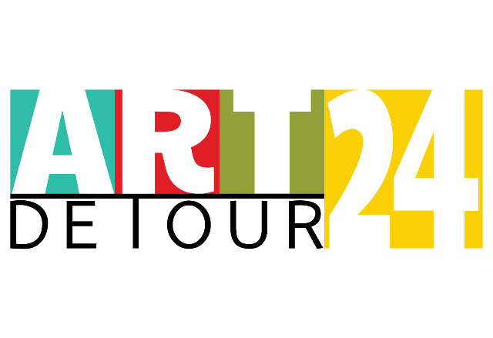

You’re invited to participate in a PUBLIC HANGING during Art Detour 24

Attn: Deadline extended until noon on March 14th!

Artlink Phoenix is proud to present a PUBLIC HANGING, a benefit art exhibition celebrating the rich diversity of artistic talent in the Arizona community. Visual artists of all ages and levels of expertise in any media are invited to submit hangable works of art. Entries will be accepted and displayed on a first come basis up to the limitations of our exhibition space, Artlink’s A.E. England Gallery at Civic Space Park, 424 N. Central Avenue, Phoenix, AZ.

The PUBLIC HANGING will take place during Art Detour weekend, March 16-18th. Proceeds will help fund ongoing programs of Artlink. The cost to enter, one per artist please, is $25.00 and includes an individual membership to Artlink.

Artwork must not exceed three (3) feet wide, three (3) feet tall, (1) foot deep and no heavier that 20 pounds. Pieces exceeding any one of these dimensions may not be hung. Each piece must be ready for hanging and pieces that require attachment of hanging apparatus may not be hung. All artwork must be self-contained and remain within the physical limits of the hanging specifications.

Once we’ve received your application, you will need to deliver your piece to After Hours, 116 W. McDowell Rd, Phoenix in person before 5:00pm on Wed, March 14th (Hours are 8am – 5pm)

Pick up day for all pieces will be the following weekend, March 24th from 12:00 noon – 5:00pm
Artwork not claimed at this time will be stored off-site with pick-up arrangements to be made.

Works on display at the PUBLIC HANGING will not be available for sale at the time of the exhibition. Prices of works will not be listed. A roster of artists will be available for reference.

To ensure your place, please send in your entry form and hanging fee (make checks payable to Artlink, Inc. or via PayPal on the Art Detour 24 page of the web site) early. Entry forms (the application to hang) and additional information can be found at www.artlinkphoenix.com

Entry forms and hanging fee can be mailed to Artlink, Inc., Attn: Public Hanging, P.O. Box 3426, Phoenix, AZ 85030-3426 If you have any questions regarding the Public Hanging, the call for entries or need general information, please call Mike Oleskow at 602-286-0468 Please leave your name, phone number and best time to reach you and I’ll try to get back within 24 hours.

The opening night celebration will be held on Third Friday, March 16th from 6:00–9:00PM at the A.E. England Gallery. All exhibiting artists, family and friends are cordially invited to attend.

